**Study of Acceleration on Varying Inclines**

REDACTED

F.W. Johnson Collegiate

STEAM 09B

STEAM Board Members

29 May 2025

# 

# **Introduction**

Acceleration is the rate of change on an object in relation to time (The Editors of Encyclopædia Britannica, 2025). Acceleration is the measure of change in velocity over time. It can only change when there is a change in speed or time. Acceleration can not happen without a change in direction or speed, even if the object is currently moving. For example, when an object comes to rest from an active speed, like a jet slowing down, it is a type of acceleration; it undergoes negative acceleration, since it changes in speed.

Acceleration is measured in meters per second squared (meters per second per second $m/s^{-2}$), showing the change of velocity per second (The Editors of Encyclopædia Britannica, 2025). An inclined plane/ramp is a tilted surface that's used to raise or lower objects by spreading the weight of the object across the plane (The Editors of Encyclopædia Britannica, n.d.).

This simple mechanism has been used back in the Stone Age to move heavy objects, such as mammoths. However, they seemed to use lower-grade slopes rather than steeper ones (Macaulay & Ardley, 2016, #). Galileo studied this topic and proved that an increase in velocity is almost always constant over time, provided that the environment of the object is the same (MacDougal, 2012, #). Understanding this topic can help decrease manual work without requiring any form of chemical energy, and only requires changing the method of the effort. It can also help find the received acceleration when facing an incline.

The purpose of this study is to explore how manipulating the slope of a flat surface acts as an advantage to speed and decreases the effort required. This study can help engineers when they make products requiring slopes.

Bridge engineers can compute the possible acceleration from the slope and compare it to the speed of the roadway and find the possible safety issues from the build. This can also help hydroelectric power plants to change the direction of water and find the best possible angle to improve the generation of energy.

For this study, a contraption of a 3D-printed ramp equipped with two sensors was used to measure the time to complete and calculate the acceleration.

This topic was chosen to be studied because the advantages of this study are often overlooked, while it can provide a lot of helpful information to real-world problems. Knowledge of these usages helps calculate the potential difference from inclines before testing it out. This study can help plot the best-fit line from received data points and predict acceleration. If calculated correctly, the measurements can be calculated in reverse, measuring upwards acceleration.

# **Methods**

A 3D model of a ramp (see Appendix A) was printed. The model was created by Tinkercad 3D designer and printed with PLA filament material. The ramp was designed to guide the ball from top to bottom smoothly. Arduino Nano Board was used to automate the ramps incline and calculations of the laser-photoresistor (see Appendix A) placed at the start and the end of the ramp. The photoresistors and laser lights are placed in the holes of the ramp. The experiment is measured by the speed at which a ball rolls down the ramp.

The 3D prints were printed separately and attached together using hot-glue. The servo was attached using tape.

**Figure 1:** *Picture of the the model (the red dots are the lasers hitting the photoresistor to sense the time)*

## 

The experiment starts when a card blocking the object from the first resistor is removed, allowing the ball to start rolling down. The timer starts when the ball passes the first sensor. Stopping when the ball reaches the second sensor, the system measures the difference and finds the time required to cover the distance. All experiments are done on the same surface from the same height at the same location, giving the same gravitational conditions. The logic for the system was programmed in C++ using the Arduino IDE.

The equations required to calculate the acceleration include:

Where: $d=distance; t=time; a=acceleration$

Final Velocity: $vf=\frac{2d}{t}$

Acceleration: $a=\frac{vf}{t}$

Direct Calculation: $a=\frac{2d}{t^{2}}$

These calculations are assuming that the object has no initial velocity (acceleration at the start)

.

Measurements

* Ramp Length: 7.55cm
* Max Height: 8.8cm
* Max Width: 4.3cm
* Weight of object (ball): 4.5g.

A card is kept in front of the cover of the laser, and the card is taken out straight to let the ball that's in front of it slide through. Using the release of the ball, the laser auto senses when the ball passes and shows that in the LED display on the side of the difference in time for the ball to cover both distances. The output is converted to distance over time. The received value is then converted to get the acceleration by using the formula:

$a=2d/t^{2}; d = 7.55$

$a = 15.1/t^{2}$

The value, being too small, is multiplied by $10^{4}$. The slope is identified using a protractor.

# 

# **Results**

Data is received from 5 tests on the same slope (See Appendix A). Each value tested is by a difference of 5° on the slope. Table 1 shows the average acceleration taken from the time on each slope.

**Table 1:** *Change of Acceleration in Comparison with Slope*

|  |  |
| --- | --- |
| Slope (degree from bottom) | Acceleration (cm/ms²) * 10^4 |
| 20 | 3.49 |
| 25 | 6.69 |
| 30 | 8.69 |
| 35 | 11.74 |
| 40 | 13.96 |
| 45 | 16.80 |
| 50 | 19.95 |
| 55 | 24.19 |

**Figure 2:** *Graph of the data collected*

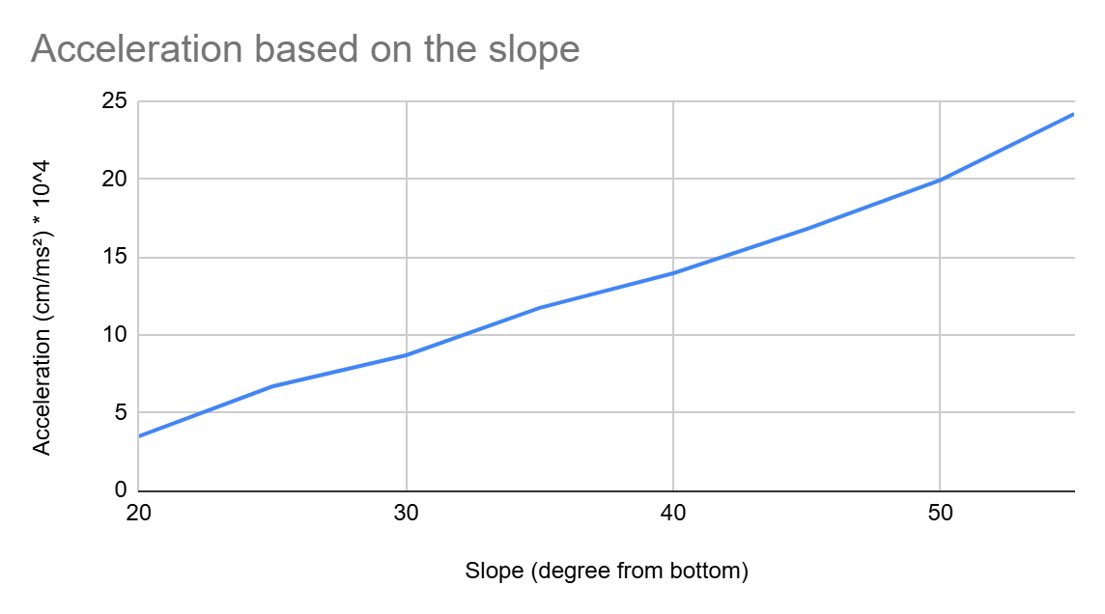

Shown in Figure 2, the acceleration increases and the inclination rises from the bottom. A line of best fit can be used on this data to figure out a common average and predict further possible slopes. The data received is limited from 20° to 55°. The data has an average increase of 2.96 cm/ms² every 5°. The data is rounded off to 2 decimal points.

# **Discussion**

The purpose of this study is to demonstrate how by manipulating the slope of a moving surface acts as an advantage to speed for less effort. To find the result of this experiment a test was done, where the results prove that, as expected, the steeper the slope, the higher the acceleration.

This would prove why people used to make longer inclines when building ramps during the Stone Age, to control the acceleration. The object wouldn't want to be too fast so people can receive the object smoothly. Being gravity makes the object fall down faster, and the ramp creates an obstruction. When the ramp gets steeper the gravity affects it more directly.

Data collected was in a specific environment using a constant object. However, the potential difference between the acceleration would be approximately equal when following the same ratio.

Overall, the data collected were approximately consistent. The results indicate that every 5º increase in slope from the bottom gives an average difference of 2.96 cm/ms-2. That is considering the current weight of the ball and the environment. Although the environment and the weight of the ball was the same throughout the experiment.

If a scatter plot is used and a line of best fit is traced on it, possible acceleration values can be predicted using the line. The collected data is limited from 0° to 90° slope. If the ramp turns around to the other side and the ball is forced through a specific hole to fit the object alone, the acceleration values start getting negative. The acceleration graphed would be shown as a parabola of $y={-x}^{2}$ where the vertex would be at 90°.

The data has minor flaws that can cause a difference in the result. When the ball is released, it's slightly behind the first laser. This increases the starting velocity by a slight bit, throwing off the calculations by a minor amount. The difference is almost equal to zero, so the possible error was ignored.

Also, the release mechanism for the object was lifting a card. This causes a minor flaw, being that it's a human that lifts the card, which might cause a small throwback. Possibly increasing the distance between the ball and the first laser compared to other tests. The increase was a small difference, if any, being the reason it was ignored.

For any further research, it’s recommended to change the model to hold the card in a fixed slot, which is in front of the laser. The ball sits on the laser that, when the card is lifted, is lifted directly up, and the ball has no initial velocity, removing all possible throw-offs from those errors.

It remains to question how curved slopes change the acceleration. Does the acceleration increase? And if so, should the object drop down first, or the object move front and then drop down? These questions can be answered if this is going to be researched further.

**References**

The Editors of Encyclopædia Britannica. (n.d.). *Inclined plane | Ramp, Wedge & Lever*. Britannica. Retrieved June 6, 2025, from https://www.britannica.com/technology/inclined-plane

The Editors of Encyclopædia Britannica. (2025, April 16). *Acceleration | Definition, Facts, & Units*. Britannica. Retrieved June 6, 2025, from https://www.britannica.com/science/acceleration

Macaulay, D., & Ardley, N. (2016). *The Way Things Work Now*. Dorling Kindersley Limited.

MacDougal, D. W. (2012). *Newton's Gravity: An Introductory Guide to the Mechanics of the Universe*. Springer New York. https://bedfordjfhs.sharpschool.net/common/pages/DisplayFile.aspx?itemId=20435049

# Appendix A

GitHub page: <https://github.com/ashstormer/STEAM-FAIR-9>

The page includes an .ino file with the code used. Opening it shows the C++ code that was used. It also contains files for the 3D model of the build and every piece divided. The circuit design is obvious, and the servo is continuous. The folder also includes the entire data of the measured information.